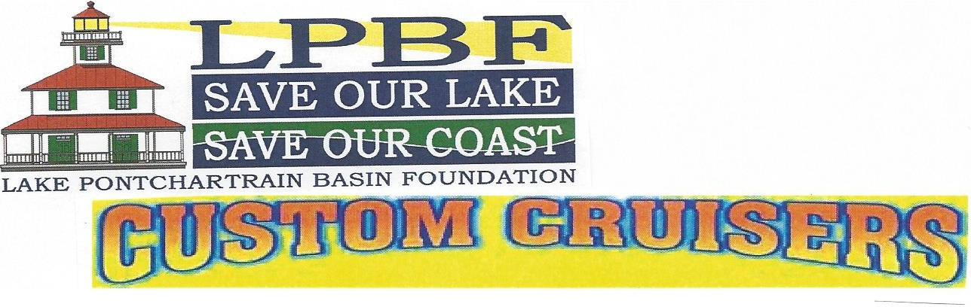
14th ANNUAL BACK TO THE BEACH

CAR SHOW

Sunday, May 22nd
9 a.m. ·4 p.m.

Laketown Kenner,Louisiana

Pre-Registration $25 through 5/18/16 Registration Day of Show $30

Top lOO Awards

Top 20 Streetrods Top 20 Corvettes Streetrods • Custom Cars • Bikes • Corvettes

Name

EMAIL: ----------------------
CIub Affiliation ------------------

Year _ Make _ Model _ Engine Color

Mail registration to Custom Cruisers, 5827 Bancroft Drive, New Orleans, LA 70122

·Make checks payable to Lake Pontchartrai Basin Foundation -NO REFUNDS!

For more information call Pam Larter ,504-282-2862 or email: wapsupplies@msn.com NO OUTSIDE CHESTS ALLOWED PLEASE

