SUNDAY, SEPTEMBER 27, 2015
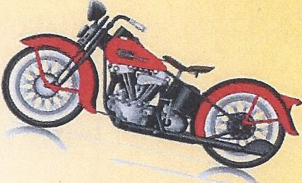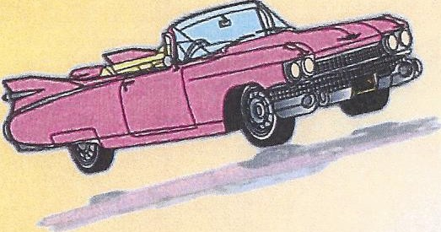8am -4pm
(Awards at 3:30pm)

LAKETOWN KENNER, LA

Awards plus "best of" awards!
Food, drink, music & door prizes!

Registration :
$20 until 9/24/15
$25 day of show (Barn-Noon)

In memory of Kaitlyn Pitfield to benefit Hemophagocytic Lymphohistiocytosis (HLH) &:'.
Stevens Johnson Syndrome (SJS)

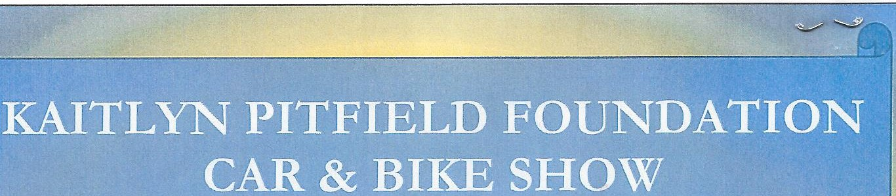

All proceeds benefit the KAITLYN PITFIELD FOUNDATION Call Pam Larter at 504,282,2862 or visit www.customcruiser.net

Make checks payable to: The Kaitlyn Pitfield Foundation
Mail to: Custom Cruisers, 5827 Bancroft Drive, New Orleans, LA 70122

Name : -------------Phone: _ _ Address: City: _ _ State: Zip: _ Email: _ _ Club Affiliation: _ Year: _ _ Make: _ Model: __
Engine: Color: __ __

