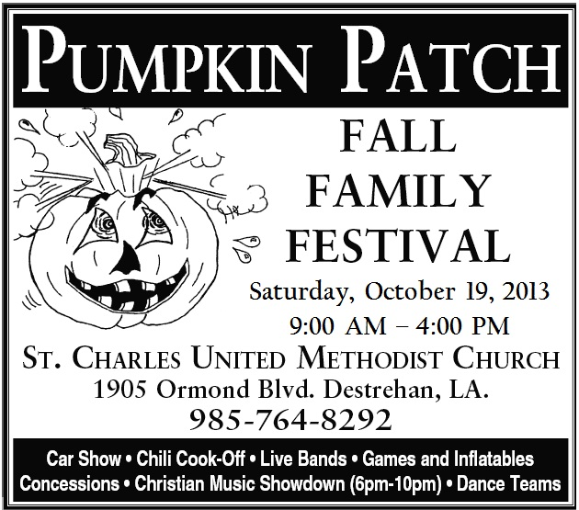
*Best of Show Trophy*
*Best Classic Car * *Best Rat Rod* *Best Custom Car*
*Mayor’s Choice Trophy*
Best: *Engine, Paint, Interior Trophies*
Top 50 Plaques
Dash Plaques (first 75)

Pre - entry $20.00 Day of show $ 25.00
Make checks payable to: SCUMC
PO Box 693
Destrehan, LA 70047-0693
504-237-1582 (Charlie)

Name:

Address: City: Zip:

Phone: E-Mail____________________________

Vehicle: Year__________Make:_________________Model:______________

By signing this form, you agree to the rules and regulations of the car show, and release the St. Charles United Methodist Church and all other parties from any liability.

Signature:______________________________________________
NO - Glass Bottle Drinks

